FinTAStic
The Angelfish Society Newsletter
Issue 9 August 2004
An Open Letter of Thanks
Stephen Hopkins

I am Stephen Hopkins. I know that because I am alive. I’m alive because when it came time to die, there were so many prayers and so much energy flowing through the heavens on my behalf that I was sent back. I know that because as I was drawn over that edge and pushed back again, I was able to hear the sound and feel the power of all that energy in my mind. So even though I crossed over that barrier between eternity and mortality, I was sent back. I am here because of all of the people who prayed for me, who cared and sent their love and healing energy on my behalf.

I have never experienced anything even remotely close to what has happened here with the members of this group. We are not just an organization. We are not just a group of hobbyists. We are a family and a power. Your caring and compassion helped to save my life.

Your support and help made the difference between hope and despair. I will be forever grateful and for all of my seriously changed life, try my best to show that appreciation and return the love, caring and help that were given to me and mine.

I am still healing and have a ways to go before I can say that life is normal again. But, I will do it and I will have my life back. I am happy to be alive. I am glad that it was me and no one else. I wouldn’t want to experience what the people who love me went through.

So I offer this promise to all of you. I am here for you. My prayers and compassion, my help are always here for you and yours. I have nothing but love and respect for you and I will always think of you as family. You should all be proud. You are all in the book of heroes.

Sincerely,
Stephen Hopkins

The Shipping Experiment
By Don McCumber
The Shipping Experiment" started out as a simple idea, in a TAF-II post, titled "Shipping", in the Angelfish Care / Angelfish Breeding section. The original post was on May 25th, 2004, and it has sparked such a level of interest, that it has grown, in 3 months, into one of the largest and most popular topics ever to appear on the TAF-II forum, with almost 700 responses, and nearly 8,000 views, as of the date this is being written. It is still an ongoing topic, and new participants continue to join in the discussion, and in the experiment itself! Here is the original post, by Dave Zagwyn:
"OK everyone I have been thinking again! LOL we all know what it cost to ship fish, here is what I would like to try. I am going to rig up a tube for the fish to lay eggs on that I can slip into a bag and load up with bag buddies and meth, little water, small bag and box and ship as cheap as possible. Imagine the potential if this was to work? Hundreds of fish shipped at a low cost! Anyone want to receive the first shipment of eggs for my experiment? Dave"
The very first day, there were 12 responses from 5 different people, and it just continued from there. There has been input from professionals, such as Steve Rybicki, and from hobbyists at all levels of experience. There have been some spectacular failures in this experiment, as well as some overwhelming successes. The purpose of this article is to attempt to summarize what has worked, and what has not, in the hopes of helping others that may want to use this information for their own shipping experiment.
Dave Zagwyn has been the force behind this experiment, right from the start. A number of others have participated, and are planning to participate, but Dave has spent the most, both in terms of dollars, and in efforts. Here are his words, when I wrote to him about writing this article (this comment from Dave pretty well sums up his "team" attitude):
"Don - ...Whatever you write I am sure it will be to my liking my friend. Do me a favor though ok? Don't give me all the credit. WE did it as a team." The team members include myself (Angelsbreeder), Abby, Lori, Greg, JoAnne, Frank... "The Shipping Experiment" and the list continues. Team members are from locations as distant as Massachusetts, Ohio, Florida, Georgia, and Arizona. Inquiries have been made by others from Canada, Hawaii, the U.K., and even Australia!
The idea behind the shipping experiment is that angelfish breeders from distant locations would be able to share their best quality angels, on an equal trade basis. One of the benefits to each trader is that they would expand the gene pool of their breeding stock, improving the health & vitality of the fish they produce. Another benefit could be that they receive varieties of angels that are not available locally, while possibly being able to do the same for a breeder in a different locale. One hand washes the other, so to speak.
The purpose of this experiment has not been to make money. One of the early comments from Steve Rybicki was that he had tried to do something like this, as part of his business, Angels Plus. Shipping is always a risky venture, and Steve did experiment with shipping wigglers some time ago. Here is some of Steve’s advice, while explaining his decision not to pursue the idea further:
"It made for lots of unhappy people and I lost quite a bit of money experimenting with it. I hope you can make it work, but wanted you to know that it won't be easy."
Well, Dave Z. & friends were going to find out that Steve was absolutely right... it wasn’t going to be easy. The methods of packing have changed from Dave’s original thoughts of slipping a tube with eggs into a bag & shipping them. Some of the early experimental shipments were done using a thermos bottle, which was bagged & taped, in case of leakage, and packaged in a fish shipping styro, with plenty of bubble wrap. A couple of shipments went out on overnight deliveries, with some living fry making the trip successfully. That led to a false sense of security, thinking that we had already come up with the answers. In one disastrous week of shipping, that feeling of success was shattered. Three thermoses (or is it thermii?) were sent from various parts of the country, and all three had their glass liners arrive in shards, with every wiggler DOA.
Showing Off Your Fish
By Wayne DesLauriers
TAS President
Gene Guido is starting to make a name for himself on the tropical fish show circuit. He took first and third place at this year’s ACA's sanctioned show in the Pterophyllum class. At last years ACA 2003, he took home a third place white ribbon. He now has started to build a collection of trophies and ribbons by showing off his fish. Gene first started showing his fish at the local aquarium society meetings. If he isn't showing his fish he is sometimes now asked to judge.
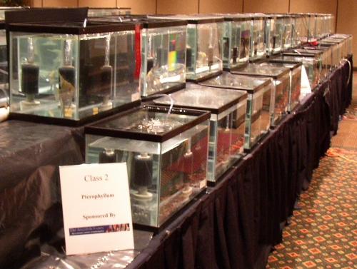
Some qualities to take into consideration when choosing a show fish is nothing more than "the best of the best" Gene says. "It should have all its fins perfect in every way and really stand out. If the fish is young and does not look exceptional, it is not going to look better when it gets large." He also added size matters in a judged competition. A smaller fish with perfect finnage will most likely lose out to a larger sized angelfish with a small degree of imperfections.

Gene became interested in the hobby at the early age of 12. He went into a hiatus in his early 20's, but at around 40 he heard there were allot of problems with the angelfish disease and "jumped back into it with both feet." He says, "The usual human disease symptoms took over with the first tank on a cheap metal stand, then one tank underneath, then a much needed second stand with accompanying tanks to make a better balance." More tanks were added up to a point where he currently has his fish room in a rented space commercial building which houses over 150 tanks holding a little over 4000 gallons! He primarily raises angelfish, but sometimes likes to dabble with a few other fish that strikes his fancy.

Gene has an associate’s degree in nursery management and has also attended a few aquaculture courses, most recently a fish health management course. Gene is a project manager for a construction company. He, along with his wife Liz, make there home on Long Island, New York. Gene Guido has been a member of TAS since May 2001.

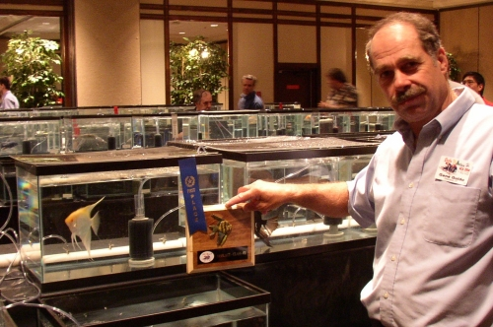

continued on page 2

Inside This Issue
1 | An Open Letter of Thanks & Showing Off Your Fish
2 | The Shipping Experiment
4 | The Antics of Angelfish & Tropical Fish Hobbyist Contest
5 | President’s Report & Some Ups and Downs of Receiving Angelfish
6 | Don’s DIY
Continued on page 3

Continued from page 1

continued on page 3

Continued from page 1
You would think that such a failure might cause a lot of people to give up, but, not this group! The immediate reaction, after the initial shock, was for people to start coming up with ideas... different thermos (no glass liners!), different packaging, spray-in foam insulation, different containers... to use Jungle brand’s "Bag Buddies", or not to use them... shipping in Kordon’s "breathing bags"... the input started pouring in.
If I covered all of the different methods that were tried, each individual success & failure, this article would quickly turn into a small book. The methods that have proven to be very successful for several of Dave Zagwyn’s shipments are as follows:
#1 - Ship as wigglers- It has been found that wigglers can actually be stronger than young free-swimmers.
#2 - Be fanatical about separating the wigglers from any unfertilized eggs. Even a few white eggs have been determined to cause the deaths of most, or all of the wigglers.
#3 - Chemical additives (such as bag buddies) seem to be unnecessary.
#4 - Wide mouth Gatorade bottles approximately 50% filled with water, and also Kordon’s "Breathing Bags" have both been used with success.
#5 - Insulate them well. Inexpensive coolers with lots of bubble wrap, styro containers, etc..
#6 - Ship overnight, and depending on weather conditions, use heat packs or cool packs.
#7 - Be ready on the receiving end, not only to be there when they arrive, but also to start a gradual acclimation process immediately.
To see the detailed suggestions for shipping, refer to page 21 of "Shipping", in the "Angelfish Care / Breeding" section of TAF-II.
The general conclusion of this ongoing experiment has been that it is a success. It has grown from Dave’s casual suggestion, into a full blown cooperative effort. Team members have traded their bloodlines, always offering the best they have, and getting the same in return. It has not always been easy, but it has definitely been worth the effort. Make some contacts, and join the team. I am glad to be a part of it, and you will be too.

Trading Goodies

Are you looking for quality angelfish at an economical price? Then look no further, Heather King our friend and treasurer has juvenile Gold Marble Ghosts, Gold Ghosts, Marble Ghosts, Chocolates, Koi & Blue Blushers as well as juvenile Dwarf bristlenose Plecto. For more information visit her website at http://www.heathersangelfish.com/forsale.htm

Do you have something to sell, trade or that you would like to buy? Place an ad in FinTAStic by just sending your ad to us at the newsletter committee at TAS_Newsletter_Committee@yahoogroups.com
Please be sure to say what you are selling, trading or what you would like to purchase and how much you are asking or hoping to pay for the items.

The Antics of Angelfish
By: Kent Hoffman
Now for a story on the lighter side of the hobby. About the antics, that some Angels can pull on you. I have two pairs of Gold’s that for the last couple weeks decided to take a vacation and play some games on me. To explain how they were able to do this I have them divided in a 29 gallon tank. The games and fun began one night when one of them decided that it wanted to see what was happening on the other side of the divider and jumped the fence. Well I decided in order to get them paired back up it would be easier on them to pull the divider and let them pair back up, instead of trying to net the right one out. Well that made them decide it was a time for a vacation, they all got together and stayed that way for awhile. After about a week of them all swimming together I noticed two of them under their slate on each side, I quick got the divider put back in and thought that their vacation was over.

After watching them for a couple days I realized that they had separated into a male side and female side of the tank, LOL. So out the divider came again and back they went for another round of sticking all together like they were tied to one another. After about two weeks now they finally decided they are ready to start spawning, again.

Now with the breeding tubes down I was able to tell them apart again and get them corralled into their respective sides of the tank. Now they are cleaning their slates and getting ready to start working again. The vacation is over for now, but knowing the personalities of my Gold’s and their passion for showing off every time you go by their tank. They will probably decide to go on another vacation after they have been spawning for awhile again. So I can probably expect them to goof off again as soon as I think they enjoy the extra attention they receive when they do so and look forward to it.
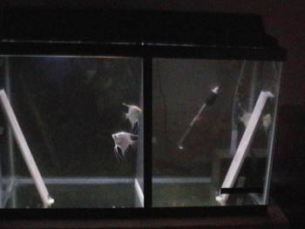
Here they are now finally back in their respective sides of the tank. And the next picture shows them getting back to work.

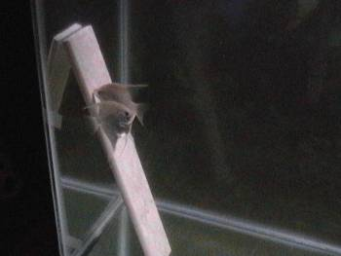
They seem to be happier now after their vacation and even happy to be back on their own sides of the tank. Have a wonderful time keeping your Angels entertained. Enjoy the newsletter and watch for the next issue you never know what will be the topic of the upcoming stories.

Tropical Fish Hobbyist Contest!
Subscription Contest Run by Tropical Fish Hobbyist Magazine
By Susan Edmonston

Below you will find an excerpt from the email from "Tropical Fish Hobbyist", we have been contacted with the information on a program which gives each member a discount on the magazine & TAS an earning potential of 25% from the subscriptions. There is also a prize of 3 of the TFH books for the winning club. I need the numbers who wish to participate in this program. So read the email and get back to me ASAP as the contest is already running. The contests ending date is late December. Contact Susan Edmonston at starsdawn_tas@bellsouth.net for more information. Thanks in advance.

This program works as follows: For every subscription to Tropical Fish Hobbyist sold, your organization earns 25% commission! In addition to earning this money, we're running a special contest. The organization who sells the most subscriptions between August 1st and December 31st will win a great prize: 3 premium titles from T.F.H. Publications, Inc.

We would like to have all of your members participate in this contest! Not only will they receive Tropical Fish Hobbyist, the leading aquarium magazine for over half a century, but they will help their organization earn money! The contest kit provided to you at your request includes letters and subscription cards to be sent out to each member. Not only are we providing you this kit but for each contest letter sent out, we will also pay for your postage! Send us your receipts and you will be reimbursed!

President’s Report
Wayne DesLauriers

First of all I want to apologize for the lack of “fun stuff”, available at the members meetings. Since TAS has become incorporated, the board has basically had to learn how to run a corporation conforming to both the IRS and the state of New York. This is/was a demanding task for all of us, which required lots of time researching the legalities and keeping in accordance with the regulations. I would like to thank all who helped out on the board who has done so. At this months meeting there was lots of praise for the "Color Mutations" presentation. Part two of the color mutation will conclude at next members meeting in September.

Current improvements have made in regards to available information happening in TAS with the new official forum. If you have not yet registered, I encourage you to do so. The secure forums poll software is what we will be using for the upcoming elections in December as well as the current photo contests. I must remind you, when registering, please use your membership name when you joined TAS (First & Last). Once you have registered and your details have been checked, your account will be granted permission. Once activated, you may go to your profile and use a nickname should you so wish. If you belong to a committee, please check your section frequently. If you are a member and have a committee question, please post your question in the corresponding section. If you are having difficulty, a new user information center has been created here: http://www.theangelfishsociety.org/newdesign4.htm

I must also encourage the members to respond to our certificate of compliance if you have not yet done so. http://theangelfishsociety.org/members/membersagreement.htm

The experience gained by going to other hatcheries and seeing their setups and talking with them of their experiences has been most enjoyable and educational. The farthest I have traveled after Angels has been over 600 miles and I retrieved some excellent Gold Marble Pearlscales, Marbles, and Smokeys. Going and retrieving them myself I arrived home with only one fatality which I thought was very satisfactory. The accumulation of knowledge that is retrieved on such a trip is well worth the trip if you enjoy your Angels as much as I do.

I have had other Angels shipped to me and though they come from very respectable people and are packaged as well as possible the shipper can devastate you when they get there. I had a large shipment of Gold’s, Gold Pearlscales, Black lace, and one DD black. When they had arrived at my house the package had been overturned and shoved around enough during transit to show the abuse on the outer packaging, the result of this handling was the loss of over half my Angels. To say the least I was heartbroken and outraged at the way they handled the package.

As a group we need to somehow get the shippers to acknowledge that they need to take cares with the packages that we trust them to get across country for us. They have labels for handle with care fragile and this end up that they do not take them time to look at because they have no care other than to get it to you so they can get home from their job. They are the link for us between many enthusiasts and breeders that we have to use in order to carry out our obsession with these beautiful fish that we love and for some to promote their businesses.

We need the shippers to care for the packages they ship so that we can trust them to get us our Angels. With my experience with them I now tend to try and get them from somewhere that I can go to pick them up. But like all of us we will have to use shippers from time to time, but in doing so I really don’t want another experience with them like I had. The bad experience of shipping is not only the loss of valuable fish, and monetary loss, but it also the feeling associated with this loss.

I thought sharing this with all of you that the Human side of our hobby would show through and express the bad side of a loss along with the great enjoyment of the hobby. We all tell our happiest memories of caring for these beautiful fish that we all love. I know there are plenty more horror stories about shipping that can be told over and over. But thought that put at least one of them into words would express the great losses we take as a group for the preservation of our hobby, that can be inflicted upon us by the uncaring treatment of packages by the shippers that we need to use.

Some Ups and Downs of Receiving Angelfish
Kent Hoffman

In my experience getting my Angelfish, I have had to get the from some distances as our local fish store rarely has Angels and when they do usually have the same varieties all the time. So I have gotten most of my Angels by either traveling to get them or shipping them in. Traveling to different areas to retrieve some excellent specimen’s for my breeding stock has proven to be most enjoyable.
continued next column
continued from previous column
Don’s DIY
"The TLC Jar"
By Don McCumber
“Angelsbreeder”

I’m the sort of guy that’s always trying to build the better mousetrap. Sometimes I feel a need to justify what I do, when I’ve been accused of creating solutions in search of a problem. The fact is, I often find that the skeptics end up telling me, “Well... I could have thought of that!” The reason? I design things to solve my own problems, and then others seem to realize that they’ve had the same problems too. I think that this project will not be an exception to that rule.

To begin with, I have identified 5 basic problems with the usual methods of raising angelfish away from the parents. They are:
- Maintaining good water flow around eggs & babies
- Keeping the bottom clean, since that’s where so many end up
- Changing water, without sucking up babies
- “Clumping” of babies on the bottom with debris & white eggs
- Maintaining temperature stability

Another problem, beyond the basics, is in raising angel broods that were part normal color, and part albino. The albinos are often smaller and more sensitive in the first few weeks of life. They also have an unusual tendency,that a few other TAS members have corroborated. When a light shines on their tank, they drop like a rock to the bottom, while their normal color siblings keep on swimming normally. That means that every time this happens, they dive into whatever stuff might be sitting on the bottom. You just can’t siphon 5 times a day. To solve these problems, I created the Tender Loving Care Hatching Jar.

The TLC Hatching Jar sets inside of a well-cycled, temperature-stabilized 10 gallon fry tank. This fry tank is complete with a sponge filter, and a few fish to maintain the biofilter. The TLC Jar has a wall-to-wall sponge filter of its own, near the bottom of the jar. Water flows into the TLC jar through 4 - 5/8" holes, just under the water line, that have pieces of sponge stuffed in them. From there, the water flows down through the sponge filter bottom, and exits through a riser tube, which starts at the center of the sponge, exits the jar, and then turns upward towards the surface. An airline powers the riser. The airstone inside of the jar is bubbling gently, to break the surface tension.
continued in next column
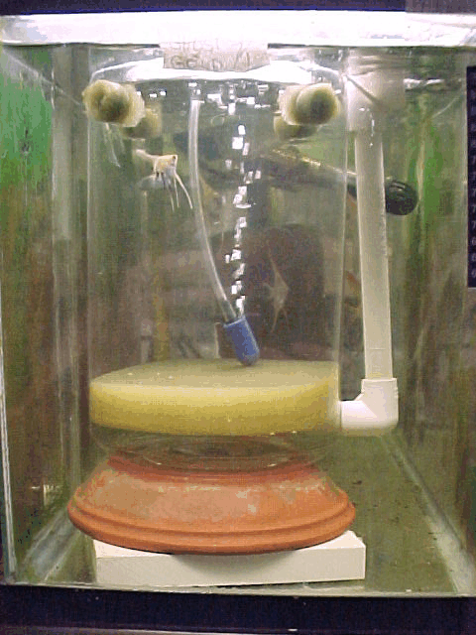
I have found that the TLC Hatching Jar helps to solve the problems that I have outlined here.
- There is a constant, gentle flow of water through the entire jar.
- The bottom stays clean, since the small particles that normally accumulate are drawn into the sponge filter.
- Water changes are simple. Just change the water in the tank and the jar water is changed at the same time, without sucking out any fry.
- The fry don’t have that tendency to roll around the jar until they gather in clumps. Usually, they stick to the sponge wherever they fall. Here is the main point - when they do fall to the bottom, they don’t accumulate in areas with less flow, because the entire bottom is circulating. There are no “dead spots”. Since the fry tend to stick to the bottom singly, 2 other problems can be addressed more easily.
  - the white eggs are easier to remove
  - normal color siblings can be removed, leaving the albinos with less competition
- The temperature in the jar is as stable as the tank it is in.
An unforeseen benefit of the TLC Jar, is that it makes a pretty good starter nursery for a small to medium-sized brood of free-swimmers. When you feed bbs, the fry aren’t scattered all over a tank - they’re concentrated in a fairly small area. When the bbs drop to the bottom, they still have water flowing over them, so they stay alive longer, to the benefit of the fry. And you don’t get that gooey orange slime (I just love these technical terms!) on the bottom.

continued on page7

About the only problem that I have with the TLC Hatching Jar is, I like it so much, I need to make about 5 more! At a cost of around $6 each, that’s not too bad of a problem. If you’re telling yourself that you can’t live without one, it’s not that hard to make. Here goes:

Materials:
1 gallon clear plastic jar - Wal-Mart $3.97
1" thick sponge - fabric store 50 cents
½" PVC - home center $1.19
½" PVC elbows (2) - “ ” 29 cents each
stainless steel machine screw, washer, & nut
clay saucers, or ceramic tile, or? (Be creative!)

To cut the sponge, I sharpened the edge of a large coffee can, to make a cutter. The can is just larger than the diameter of the jar, so the sponge fits snugly, without any adhesive. To see an explanation of how this is done, go to TAF-II, to the DIY section, and read “Don’s Sponge Filter Towers”. The first sponge that I cut was angled a bit, so I was more careful to hold the coffee can straight, and the second one fit perfectly. 5 holes need to be drilled in the jar. 1 near the bottom, for the riser tube, and 4 below the water level in the tank. I used a 5/8" forstner bit, since they cut such neat holes. The outside diameter of the PVC is 5/8", so it makes a tight slip-fit. Plug the top holes with pieces of sponge that are cut a little bit oversize, for a tight fit. I attached a piece of marine-tex plastic to the jar, but found that it was too close to neutrally buoyant, so I drilled a hole through a clay saucer & added that for the height & weight. You definitely need the weight, since, due to the outflow of water from the riser tube, the water level inside of the jar will always be lower than the water level inside of the tank. If you don’t have enough weight, or you have the bubbler going too strongly in the riser, your jar can become buoyant & tip over! (Been there, done that!) The plastic and the saucer are screwed to the jar using a stainless steel machine screw, washer & nut. You can have the riser tube open at the top, or drill a hole in a 90 degree elbow for an airline, like I did, and direct the flow of water with the elbow.
If anyone needs the kind of step-by-step DIY that I have done on TAF-II before, I have a whole series of pictures that I can post. As always, with any DIY project, please feel free to innovate. We may not have the same tools, and we may use different methods. You might find a better way to do this, and your version might address some issues that never occurred to me. If so, I’d love to read all about it! See you on TAF-II.
Newsletter Committee:
Wayne DesLauriers
Susan Edmonston
Don McCumber
Kent Hoffman
Juanita Hoffman
Stephen Hopkins
Nick Gonzaga

Disclaimer: Opinions expressed herein are those of the authors and not necessarily from TAS. No reprints without TAS and the author’s permission.
- Newsletter submission: Send articles and announcements by email to Nick at nigonz@att.net

- 2004 TAS Meeting Schedule: Every third Sunday at 9:00 p.m. EST. The exception to the meeting dates is: December 21st (Christmas) will be December 14th.

- Meeting Place: All of the meetings will be held in the TAS meeting chat room. Check TAS website for instructions to access the chat room.

- Annual Dues: $5.00

- Membership: To become a member of The Angelfish Society, or to renew your membership for the current year, please send your $5.00(U.S. Funds) membership fee via check or money order payable to “The Angelfish Society” at the address below.

TAS-Heather King
1110 W. Lill Avenue
Chicago, IL 60614

